

Product Dissection for Flipkart

**Company Overview:**

Flipkart Private Limited is an Indian e-commerce company headquartered in Bangalore. It was founded in 2007 by Sachin Bansal and Binny Bansal and registered in Singapore as a private limited company. Initially started as an online bookstore before expanding into a large range of product categories including electronics, fashion, groceries, and home essentials. In 2018 it was acquired by Walmart and enhanced its capabilities and resources in the e-commerce sector.

Now it is one of India’s leading e-commerce platforms, recognized for its extensive product offerings and customer service and holding 48% market share as of 2024.

### **Product Dissection and Real-World Problems Solved by Flipkart:**

Product Dissection involves a breakdown of various components, features, and functionalities to understand how it works.

Flipkart, one of India’s most popular e-commerce platforms, has encountered various challenges since its inception in 2007. Now we will cover a structured overview of these challenges, and the strategies employed to overcome them.

* **Electronics**: A wide range of products including smartphones, Watches, Tablets, Laptops, and accessories from leading brands.

Regularly providing top offers and discounts on electronic items and gadgets to attract customers.

* **Fashion**: Extensive collection of apparel, footwear, and accessories for men, women, and children.

Collaborating with local and international brands, along with exclusive collections and seasonal sales.

* **Home & Kitchen**: Diverse selection of furniture, Home decor, Kitchen appliances, and cookware.

Focused on quality and affordability with a variety of options for all categories of customers.

* **Books and stationery:** Awide range of books and stationery with multiple genres, including best sellers, academic textbooks, and multiple novels and literature.
* **Groceries and Essentials:** Online Grocery shopping option with attractive offers and discounts on different -different grocery products and top discounts on card payments and UPI payments.
* **Sports and Fitness products:** There’s a huge collection of healthcare products like health supplements, fitness equipment, Sports equipment, and activewear.

Collaborated with top sports & fitness brands to offer exclusive products and deals.

* **Toys and Baby Products:** Wide selection of Toys and games, and baby products for different age groups, also an emphasis on the safety and quality of products. With options for educational products and deals.
* **Beauty & Grooming products:** A variety of beauty products, skincare products, and grooming essentials from popular brands.

Focused on customer reviews and ratings to enhance the quality of products.

* **Customer-centric Features:** User-friendly interface and search functionalities with personalized recommendations based on browsing history.

Easy return policy, and COD payments facility for new users, enhanced customer shopping experience.

### **Case Study: Real-World Problems Solved by Flipkart**

**1. Trust in Online Shopping:** Initially,people hesitated to purchase products from online shopping due to concerns about product quality and payment security.

**Solution**:

Flipkart introduced COD as a payment method, allowing customers to pay for their orders only upon delivery. This approach significantly reduced the fear of online fraud and encouraged hesitant customers to make purchases, as they could inspect the product before payment.

For larger and expensive products such as electronics items, Flipkart introduced the open box delivery system, which impacted a lot when the product got delivered, then the customer could check the product before accepting, and once the customer is satisfied, they only make payment.

**2. Limited Product range:** Initially focused on books, Flipkart faced the challenge of expanding its product categories.

**Solution:**

Gradually diversified into electronics, fashion, home essentials, Toys & Baby products, Sports & Fitness products, and Beauty and grooming products, significantly expanding the product categories and options available for each specific product. By collaborating with local sellers and distributors for various products, Flipkart enabled them to sell their items on the platform, allowing these sellers to earn money through profit margins.

The launch of Flipkart Grocery was a significant milestone for the company, expanding its offerings to include essential grocery products. This move addressed the growing demand for online grocery shopping, providing customers with convenience. The aim was to target city customers who have busy lifestyles.

**3. Logistics and Delivery issues:** As we all know, in the early days of online shopping, it was often challenging to receive products on the promised delivery date, leading to frequent delays. This inconsistency significantly impacted customer trust.

**Solution:**

Flipkart established a robust logistics network that includes fulfillment centers and partnerships with local delivery services to enhance delivery efficiency. Later, the company invested heavily in building its own logistics network, Ekart, to ensure timely deliveries. Additionally, the company opened multiple Flipkart Hub centers in various cities, which streamlined the delivery process and made it more efficient.

**4. Easy Returns and 24/7 customer support:** In the early days of online shopping, many consumers were hesitant to make purchases due to concerns about the return process. If customers received a product they didn’t like or that didn’t meet their expectations, returning it could be a complicated and frustrating experience.

**Solution:** Flipkart has addressed this issue by implementing a user-friendly return policy. Customers can easily initiate returns or request replacements if they are dissatisfied with their purchase. To process a return, customers simply need to provide a valid reason for the return or replacement.

Additionally, Flipkart offers 24/7 customer support to assist users with any issues they may encounter during the return process. Whether customers have questions about their return status or need help navigating the return procedure, they can reach out to customer support at any time. The dedicated support team is committed to ensuring a smooth and satisfactory resolution for every customer, enhancing their overall shopping experience.

**5. Addressing high returns:** In the initial years, when Flipkart was still learning about Indian customers, the company faced significant challenges with high return rates. Many customers would order products and return them simply because they didn't like them, which created substantial issues for Flipkart.

**Solution**: Seller verification: Flipkart established a rigorous verification process for sellers that ensures only legitimate seller can sell their authentic products.

Enhanced Product Quality, Descriptions, and Images: Flipkart improved product listings by providing authentic quality products, detailed descriptions, and high-quality images, allowing customers to make more informed purchasing decisions and reducing the likelihood of returns due to dissatisfaction.

**6**. **Fraud at Flipkart:** Some customers engaged in fraudulent activities by ordering authentic products, replacing them with ordinary or used items, and then claiming replacements or returns. This not only wasted valuable time but also incurred financial losses for Flipkart.

**Solution**: Open Box Delivery for High-Value Items: For certain high-value products, Flipkart introduced open box delivery, allowing customers to inspect items before accepting them. This practice minimized the risk of fraudulent returns

Legal action against fraudsters: Flipkart started taking legal action against fraudsters First, they identified them using advanced algorithms and machine learning to monitor transactions for suspicious activities, enabling real-time detection and prevention of fraud. Then, if caught, they acted.

**7. Rivalry with competitors:** When Flipkart entered the market, Amazon and eBay were already dominant players in the online shopping space, presenting a significant challenge.

**Solution**:

However, Flipkart implemented innovative strategies focused on understanding customer demands and enhancing satisfaction by offering a diverse range of options for any specific product.

Big Billion Days Sale: Flipkart's flagship sales event, the Big Billion Days, was designed to create significant buzz and attract customers, often leading to higher sales volumes than Amazon's competing events (Great India sales)

Exclusive Partnerships: The company formed exclusive deals with smartphone manufacturers, offering interest-free loans and special promotions, which helped Flipkart capture a significant market share in electronics.

Investment in Technology: Flipkart focused on enhancing its technology stack, improving user experience through better app functionality, personalized recommendations, and efficient payment systems.

**Conclusion**: The case study of Flipkart highlights how the company has effectively tackled various challenges in the Indian e-commerce landscape. By introducing solutions like Cash on Delivery (COD) and open-box delivery, Flipkart built trust among hesitant consumers and enhanced the online shopping experience. The expansion into diverse product categories, including Flipkart Grocery, catered to the needs of busy customers. Additionally, a robust logistics network and a user-friendly return policy improved delivery efficiency and customer satisfaction. Through rigorous seller verification and enhanced product listings, Flipkart addressed high return rates and fraud, ensuring a secure shopping environment. By adopting innovative strategies and exclusive partnerships, Flipkart successfully navigated competition from established players like Amazon and eBay, solidifying its position as a leader in the market.

**Top Features of Flipkart:**

* **User-friendly interface:** Flipkart introduced a user-friendly interface for both the app and website for customers and provides personalized product suggestions based on our searched browsing history.
* **Wide product range:** Flipkart provides a vast selection of products across various categories, including electronics, fashion, home essentials, and grocery.
* **Fast and reliable delivery:** Flipkart has developed a robust delivery system named Ekart, which provides fast, doorstep delivery and an order tracking facility, in which customers can track their orders by order ID.
* **Multiple payment options:** Flipkart provides multiple payment options for all age of for aged persons, COD (cash on delivery), and for other card payments, Credit/Debit cards, UPI payments, and for expensive products, it provides an EMI facility as well.
* **Top offers and discounts:** Flipkart provides Top offers on top brands. It offers a variety of discounts on different banks' Credit/Debit card payments. Flipkart frequently hosts sales events like the Big Billion Days, offering significant discounts and deals.
* **Innovative Technologies:** Flipkart always makes changes according to the needs of the time. It provides Image search so customers can find products related to the uploaded image, voice search, which saves time for customers, and a Machine learning algorithm for suggesting products based on previous browsing history.
* **24*7 customer support:** Flipkart provides 24*7 customer care support If customers have any queries or face issues while ordering or returning items, they can connect to support at any time and provides a multi-language facility so customers can communicate in their preferred language.

#### **Flipkart Schema Description:**

#### **1. Customer Entity**

Purpose: Represents user information on the Flipkart platform.

* Customer_ID: Unique identifier for each customer.
* Customer_Name: Preferred name for each customer.
* Email: Email address for account-related communication.
* Contact_Number: Unique contact number for account-related communication.
* Full_Name: Full name of the customer.
* Registration_Date: The date when the customer registered on Flipkart.
* Customer_Address: The address provided by the customer on Flipkart.

#### **2. Product Entity**

Purpose: Contains information about products available on the website.

* Product_ID: Unique identifier for each product.
* Product_Name: Name of the product displayed on the website.
* Product_Description: Detailed information about the product.
* Price: Price of the product.
* Category_ID: Foreign key linking to the Category entity.
* Seller_ID: Foreign key linking to the Seller entity.

#### **3. Category Entity**

Purpose: Represents different product categories on the website.

* Category_ID: Unique identifier for each category.
* Category_Name: Name of the category displayed on the website.

#### **4. Order Entity**

Purpose: Contains information about customer orders placed on the website.

* Order_ID: Unique identifier for each order.
* Order_Date: Date when the order was placed.
* Order_Amount: Total amount for the order items.
* Order_Status: Status of the order (e.g., confirmed, pending).
* Customer_ID: Foreign key linking to the Customer entity.
* Product_ID: Foreign key linking to the product entity.

#### **5. Seller Entity**

Purpose: Holds information about sellers on the Flipkart platform.

* Seller_ID: Unique identifier for each seller.
* Seller_Name: Name of the seller.
* Seller_Number: Contact number of the seller.
* Seller_Address: Address of the seller.
* Product_ID: Foreign key linking to the product entity.
* Category_ID: Foreign key linking to the Category entity.

### **Relationships**

* Customer to Order: One-to-Many (A customer can place multiple orders).
* Product to Category: Many-to-One (A product belongs to one category).
* Product to Seller: Many-to-One (A product is sold by one seller).
* Order to Customer: Many-to-One (Many orders are placed by one customer).
* Customer to product: One-to-Many (A customer can purchase multiple product)

**E-R Diagram:(Entity-Relationship Diagram):**

The Entity-Relationship Diagram (ERD) for Flipkart is a visual blueprint that encapsulates the intricate relationships between various entities within the platform. This diagram illustrates how customers interact with products, orders, and other key components of the Flipkart ecosystem.

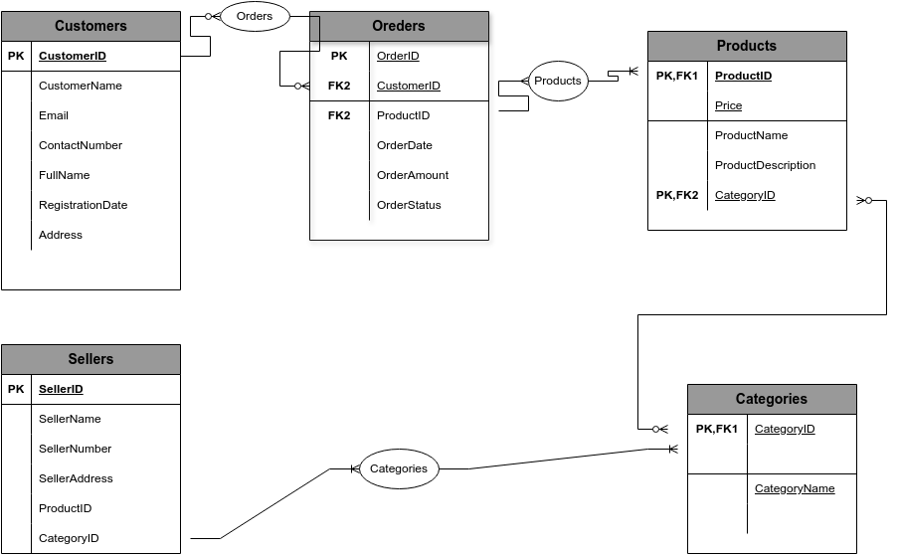

**Conclusion:** In this case study, we explored the design of the schema and the Entity Relationship Diagram. In conclusion, Flipkart has become a top e-commerce platform in India by successfully tackling various challenges since it started in 2007. It built trust with customers by offering options like Cash on Delivery and open-box delivery. The company expanded its product range and improved its delivery system, making shopping easier for busy customers. By ensuring quality through careful seller checks and better product descriptions, Flipkart reduced fraud and returns. Overall, its focus on customer needs and smart strategies has helped it grow and succeed in a competitive market.